**DATABASE TASKS**

Create an ER diagram for School management system - NSS

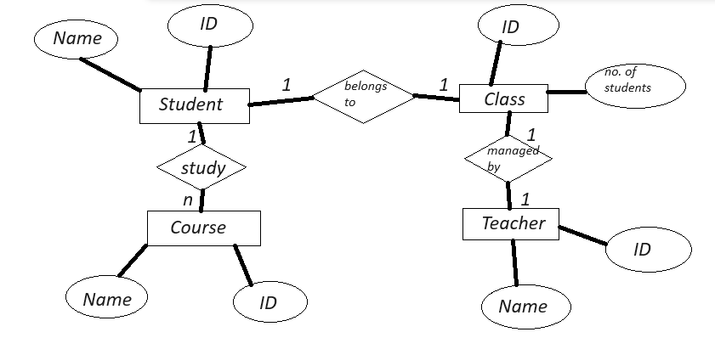

Setup the Postgre on your machine and create a DB.



Add tables respective to ER diagrams



Write a Select query with and without conditions.

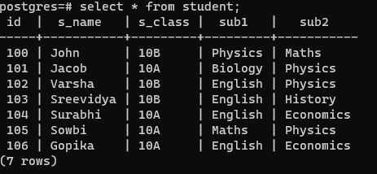

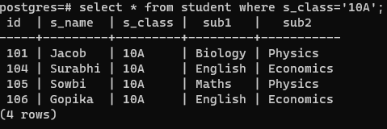

Write an insert query to add new data for all the tables .

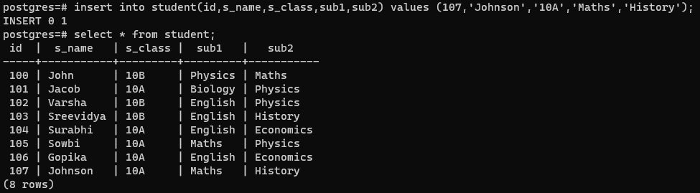

Write an Delete query to delete any existing data for all the tables.

